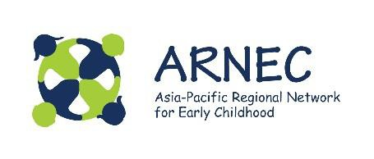

Ecological resilience and wellbeing in the early years:
Mitigation of climate change as a child’s right.
Readings and discussion

Articles selected:
- Helen Clark. Governments of the world must prioritise children, amid climate change.
- Kelly Ann Naylor. Climate change – induced water insecurity endangers children.
- Richard Louv. There are huge risks in raising children under what amounts to house arrest.
- Jantirar Abay. In Addis Ababa learning through outdoor play.

We ask you to read the first reading by Helen Clark, and select one other reading from the group. The selection of this 2nd reading will depend on what you believe the most relevant for your context and culture.
In your group, join with other teachers and interested people to discuss the content of each article. The template below is intended as a guide for your discussion. Please appoint a member of the group to take notes and to record the key points of discussion for each article. You may also answer the questions as an individual.

What have we learnt?
Consider the following questions as you engage in thought and/or conversation.

What were my/our understandings of climate change and its impact on children before I/we read this material?

What interested me/us before we read this material?

What challenges arose from the readings?

How are children in our local community and culture impacted by climate change?
What is the unique character of your local setting and culture?
What do I /we now understand by mitigation* of climate
change as a child’s right?

*To mitigate means to lessen or moderate

What key messages did I/we obtain from this material?

How has the reading influenced my/our thinking?
In my/our work with young children, what will I/we do differently, now that I/we have this new knowledge and understanding?

As early childhood teachers who are part of a community, how can I/we:
- Promote ecological resilience
- Improve wellbeing
Do you have any further comments, questions, concerns?

